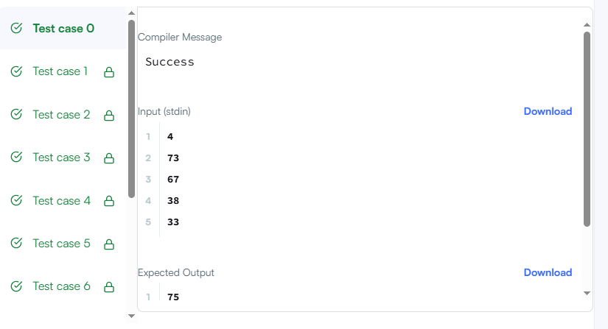
CODE-

int main() {
int n, grade;
scanf("%d", &n);

for (int i = 0; i < n; i++) {
scanf("%d", &grade);

if (grade >= 38) {
int next = ((grade / 5) + 1) * 5;

if (next - grade < 3) {
grade = next;
}
}

printf("%d\n", grade);
}

return 0;
}

LINK-

https://www.hackerrank.com/challenges/grading/problem

